How to Add a Zoom Background

First, open Zoom. At the top right, there will be a gear icon. Click that icon to open up the settings menu.
Once settings have been opened, there will be a menu option on the left called “Virtual Background” – this is where the background that is displayed during Zoom calls can be changed.
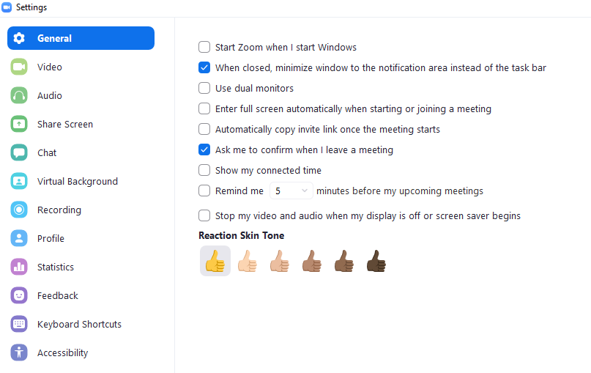
To add a new Zoom background, click the “+” next to where it says “Choose Virtual Background.” This will open a window where saved images can be selected from any file location to use.
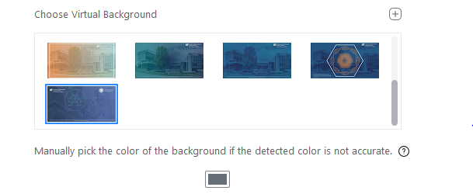
Some computers may require a solid color background like a green screen before a virtual background is able to be used successfully.

How to Use a Zoom Background

Once the desired image has been uploaded, simply select it and that image will show up as a default background the next time a Zoom call takes place. The selected background will appear highlighted in blue.
To remove this background, scroll up in the “Choose Virtual Background” pane and select the option that says “None.”

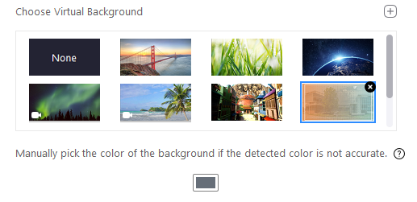

Switching Zoom Backgrounds during a Call

To switch the selected Zoom background while already using Zoom, open the Virtual Background menu by clicking the arrow next to the video button on the left-hand side of the menu at the bottom of the Zoom screen.
A new menu will pop-up that will include the option to “Choose Virtual Background.” This will direct back to the Virtual Background menu where a new background can be chosen from any uploaded files or any default options provided by Zoom.

